http://www.tutormentorprogramlocator.net/portal2008/secure/admin/program-locator/account/profiles.asp
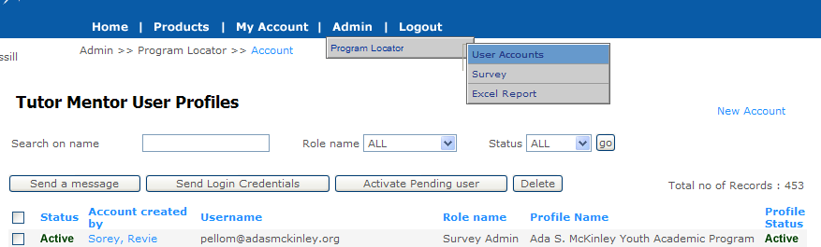
ADMIN --> PROGRAM LOCATOR --> ADMIN - "Tutor Mentor User Profiles" page
- This "Tutor Mentor User Profiles" page is still under construction.
- Since 1 user will have multiple surveys/profiles assigned to him, PROFILE NAME column will no longer be hyperlinked. Multiple profile name will be listed (text will be wrapped)
- NETWORK ADMIN user can/should do only activities related to user

Idea behind the screen changes is as follows
ADMIN --> PROGRAM LOCATOR --> ADMIN - then click the user name "Tutor Mentor User Profiles" page → "Edit Personal Profile" Page

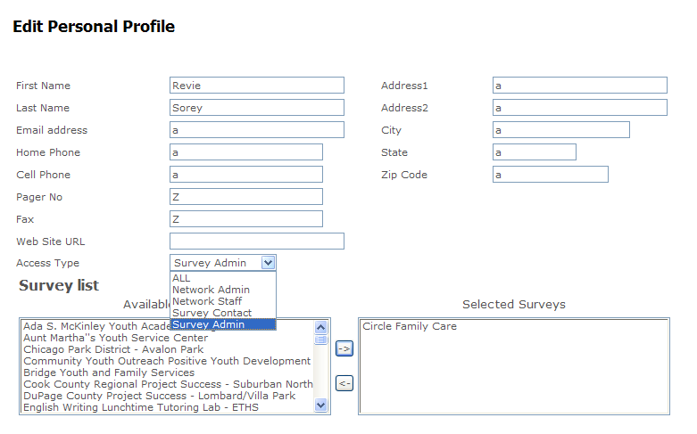

"Edit Personal Profile” page is under construction and you should be able to
1) Change all information related to the user.
2) Change user's role name
3) Add or remove the surveys assigned to user
Dan Question: This is a possible situation.
For a survey Mr. Sorey is the only SURVEY ADMIN and since he created the survey, his name is there as “Contact Person” also. In this case should we allow the NETWORK ADMIN to remove a user (Mr. Sorey) from a survey.

If we allow this, there will be a survey without any contact or survey admin
Or we can prevent this situation by not allowing the NETWORK ADMIN to remove the survey for Mr. Sorey

Let’s make sure we are clear in understanding that the NETWORK ADMIN is a person on my staff who can edit anything, while the NETWORK STAFF is a person with a single (or multi site) organization, who can ONLY change the information for his/her surveys.

So that we can avoid further confusion, “NETWORK STAFF” should be referred to as “SURVEY STAFF”.

The NETWORK ADMIN should be able to add/delete. Leave permission to change in.

The people administrating the survey for the program listed (Survey Staff & Survey Contact) can choose to have no contact person shown on their survey, but they must keep an email address in the survey.

Question. If we change the role of someone from Survey Staff to Survey contact, does this automatically change that information on the survey?

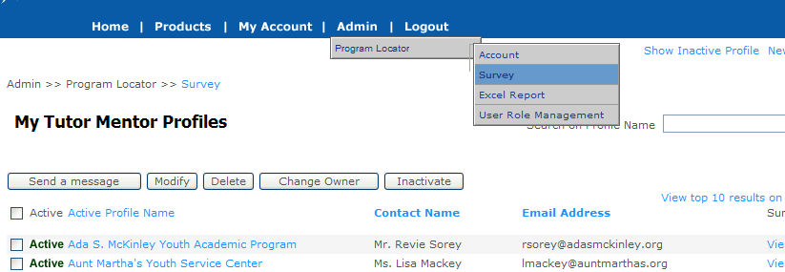

ADMIN --> PROGRAM LOCATOR --> SURVEY - "MY Tutor Mentor Profiles" page
- 1 Profile have only 1 SURVEY CONTACT, the user name is listed in the list
- Survey Staff user can/should do only activities related to their own SURVEY/PROFILES in this screen
- Network Admin (my staff) can change any of this information

ADMIN --> PROGRAM LOCATOR --> SURVEY - "MY Tutor Mentor Profiles" page → Click “Active Profile Name” link, you will be taken to “Tutor Mentor Program Survey” page.
Tutor Mentor Program Survey – PAGE
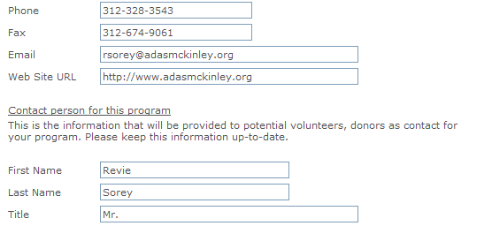

DAN – Question:
- To avoid misspelling in name, phone numbers and email id fields– DROPDOWN will be a best way to do it.

We can use registered user screen to get SURVEY CONTACT user also, we are collecting his/her email id, phone number, name and others – So in the DROPDOWN, can we use the registered user list with “SURVEY CONTACT” role –

- OR Should we create the SURVEY CONTACT role using FIRST NAME, LAST NAME, EMAIL fields? If YES – Can we have EMAIL field closer to the last name
- Since 1 survey may have more than 1 survey admin, should we list them in a list box? NETWORK ADMIN user can ADD/Remove the user (SURVEY ADMIN) who has access to this selected survey?

The survey is the first point of entry for most users (Survey STAFF & SURVEY Contact). Either they are creating a survey, or updating one created by them, or someone else. I’m not comfortable with giving them a drop down menu of choices to put in the name box. They should be entering the name they want, or we should be doing that.

However, if the drop down is only available to Network Administrator , then the drop down would be a useful tool.

Let’s discuss.

EMAIL Questions and Answers:

- On the Edit Personal Profile, will we need to go through each profile to link the person with the correct profile? Is there a way that this can be correct before it goes live? Right now the first name (Revie Sorey) is linked to Circle Family Care instead of Ada S. McKinley. Other names, such as Donna Mimms, don't link to anyone. Can you go through this and make sure the name on this list is linked to the organization shown on the list.

This happened because we were working on this LISTBOX feature. Now we are clearing out issues like this.

- In the same Edit Personal Profile page is see that on the Program Profile you have created a drop down list so that we can choose who to list as the contact person for an organization. Have you tested this to make sure this contact information will display correctly on the Program Locator search engine?

We thought of doing this as dropdown – but we had some questions –
- Do you want to enter the SURVEY CONTACT as in text box or
- should we ask the user to register and then we can created DROPDOWN in survey – were NETWORD ADMIN user can change the contact for the survey.

Like to know which one is easier for you. We can talk about this. Let me know the time

A SURVEY Contact or Survey Staff should be able to go to the survey and change the name and email (or anything else) related to the survey and those changes should update information elsewhere.

If there is a change of Survey Staff, such as email address, they should be able to log in and make this change. Or the Network Admin should be able to make the change. A drop down menu is not useful for Program Locator contact information because it is not likely that any contact or staff will be connected to any other survey.

Question. Value of drop down menu for programs.

A drop down menu of surveys is useful because (why?) list

- When I click "change owner" then click on Revie Sorey, this takes me to the place where I can change this name. However, this does not seem to be connected to the email address shown with that name in the tutor/mentor profile. When I change the acount person's name I should also be changing the email address associated with this name.

Pages created for “T/MC User Account” page and “Edit Access Type” page will be removed – these functions will be incorporated into ADMIN --> PROGRAM LOCATOR --> ADMIN - "Tutor Mentor User Profiles" page

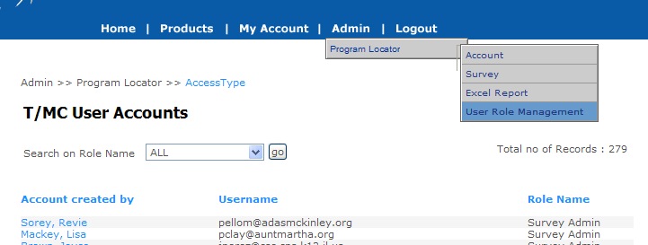 | 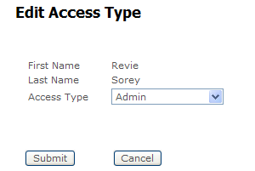

- When I click on the 'profile' via this section the contact person format is different than when I clicked on the profile via the "edit personal profile" section. Is this two different profiles?

“Profile” section hyperlink will be removed – this page was done because we had some issue with listbox in "edit personal profile" page. After some work, LISTBOX is working now and so “PROFILES” hyperlink will be removed.

Comments from Nicole and Chris:
- On Tutor/Mentor User profiles, for all the sites that have Dan Bassill listed as the network administrator, we need to be able to change the network administrator to the actual network administrator for the program with their name and e-mail address without affecting Dan Bassill’s profile.

→I am not clear on which area/page we are referring to

- My assumptions
- you are referring to sending emails to the user – instead of using dbassill@brinkster.com use the NETWORK ADMIN user email id – because in some places email name like tutormentor2@earthlink.net are hardcoded OR
- I am still researching this option – listing of “Dan Bassill” as NETWORK ADMIN in our application pages
We need to talk about this before we start working on this.

- I think one thing that would make updating things easier from our end would be if we could, as administrators, change the login credentials of users (i.e. their email addresses/usernames and passwords). I think that if we could do this, we would get more users updating their info because they wouldn’t have to go through the perceived hassle of creating a new profile and waiting for us to affiliate it with their program; We could just send them a new username and password (that they could then change if desired) and they could update their info after only one email, instead of multiple correspondences. -CW

This can be done in “Tutor Mentor User Profiles” – CLICK “New Account” link

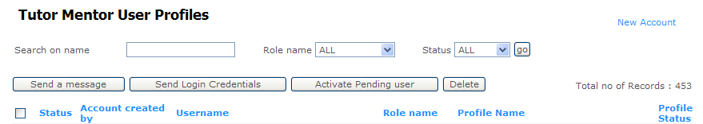

NEW ACCOUNT Page will look like this – By clicking, submit
- New user will be created
- an email will be sent to the user

Question do you want to send the selected survey information in this email?

